Excess Flow Valve Customer Notification

Beginning April 14, 2017, a new Federal Regulation requires all natural gas utilities to notify customers regarding the availability of excess flow valves (EFV).
You may request that Town of Centerville install an excess flow valve (EFV) on the gas line to your property. EFVs are mechanical shut-off devices that can be installed in the gas pipe running to the gas meter at your property (the “service line”). An EFV is designed to shut off the flow of natural gas automatically if the service line breaks, for example, by an excavation accident. Stopping the flow of gas from a broken service line significantly reduces the risk of natural gas fire, explosion, person injury and/or property damage.
EFVs are not designed to close if a leak occurs beyond the gas meter (on house piping or appliances). EFBs also may not close if the leak on the service line is small.
If you add additional gas appliances, for example, a pool heater, emergency generator, etc., the additional gas flow may cause the EFV to close.
Diagram to illustrate EFVs (Courtesy of Hubbell):

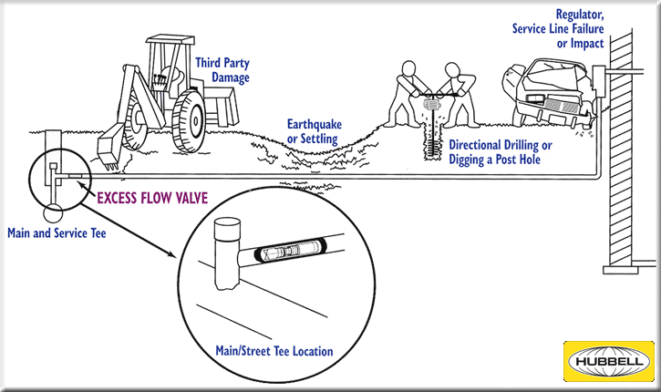

If you notify Town of Centerville that you want an EFV we will contact you to set up a mutually agreeable date when we will install an EFV on your service line. The cost that will be billed to you to install an excess flow valve (EFV) will be $1000 (One Thousand Dollars).
If it becomes necessary to maintain or replace the EFV on your service line we will maintain or replace the EFV at no charge to you.
EFV replacement may be necessary if you add additional gas appliances, such as a pool heater or emergency generator that exceeds the capacity of the EFV.
EFV replacement may be necessary if the EFV malfunctions (sticks open or closed).
Industry experience is that EFVs rarely malfunction.
EFVs cannot be installed on some service lines due to high gas flow, low pressure or other factors. If you request an EFV we will inform you if your service line cannot accommodate an EFV.
EFVs will no be installed on your service lines if:
- The service line operates at a pressure less than 10 psi throughout the year;
- The EFV could interfere with proper operation or cause loss of service.
- An EFV could interfere with necessary operation or maintenance activities; or
- The capacity of the meter on the service line exceeds 3,000 cubic feet per hour.
If you request an EFV, we will inform you if your service line meets any of these conditions.
For your safety always call 811 to have gas lines and other buried utilities marked before allowing anyone to dig in your yard.

